|  |  |  |
| --- | --- | --- |
|  | **Town of Radisson** | **Policy No.** 2023-002  **Approved by**: Council |
|  | **Water and Sewer Service Lines** | **Effective Date:** Nov. 15, 2023  **Resolution No.:** |
|  |  | **Department:** Administration |

**Purpose:**

The purpose of this policy is to clearly outline the duties and responsibilities of the Town and Residents in regards to the installation, maintenance and repair of water and sewer service lines within the Town of Radisson.

**Sewer Service Lines**

**Definition**: “sewer service connection” means a service connection that connects a building on a parcel of land to the Town sewage system;

**Installation**:

* The property owner is responsible for the cost of installation of the service line from the sewer main line to the residence.
* The property owner must have prior approval for line installation from the Town of Radisson and must utilize an approved contractor.
* The installation must be inspected and approved by the maintenance foreman prior to back fill.
* Repairs to sidewalks, streets and roads will be at the cost of the property owner but material, labour and equipment may be provided by the Town and billed to the property owner.

**Maintenance & Repair**:

* The property owner is responsible for the cost of maintenance or repair of the sewer service line from the sewer main line to the residence.
* The property owner would be responsible for contacting a contractor to attend to any blockages, breakages or collapses and the costs to repair the sewer service line.
* The Town of Radisson is responsible for blockages of the sewer main line.
* Property owner would be responsible for submitting contractor measurements, **verified by the Maintenance Superintendent**, as to location of blockage. If any question arose consideration for blockage due to tree roots may be given on the following basis:

a) Measurements provided by contractor as to location of tree roots encountered;

b) Contractor must use cutter head attachment to clear line;

c) Where there are trees on both Town property and homeowner’s property which are suspected of causing blockage, Town reimbursement will be at 50%.

**WATER AND SEWER SERVICE LINES POLICY NO. 2023-02**

**Water Service Lines**:

**Definition**: “water service connection” means any water system or pipe line on a parcel of land through which water is conveyed from the Town water works system

**Installation:**

* The property owner is responsible for the cost of installation of the water service line from the water main line to the residence.
* The property owner must have prior approval for water line installation from the Town of Radisson and must utilize an approved contractor.
* The installation must be approved by the Maintenance Superintendent prior to back fill.
* The Town will provide the curb stop or water shut off valve that is required to be installed at the edge of the property.
* Repairs to sidewalks, streets and road will be at the cost of the property owner but material, labour and equipment may be provided by the Town and billed back to the property owner.

**Maintenance & Repair**:

* The property owner is responsible for the cost of maintenance or repair of the water service line from the curb stop, to the residence and all plumbing within the residence.
* The Town is responsible for the curb stop and the water service line from the curb stop to the water main line.
* The Town is responsible for the water meter only – the attaching lines are the homeowner’s responsibility.

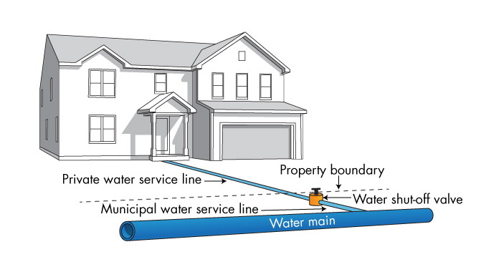

**WATER AND SEWER SERVICE LINES POLICY NO. 2023-02**

______________________________ _______________________________

Mayor Administrator

*Adopted by Council for the Town of Radisson*

*at the Regular Meeting of Council held*

*_____________, 2023*